Daniel Brooks

Data Science Math

<http://cims.nyu.edu/~kiryl/Online%20Tests/Set_78.html> Test 1

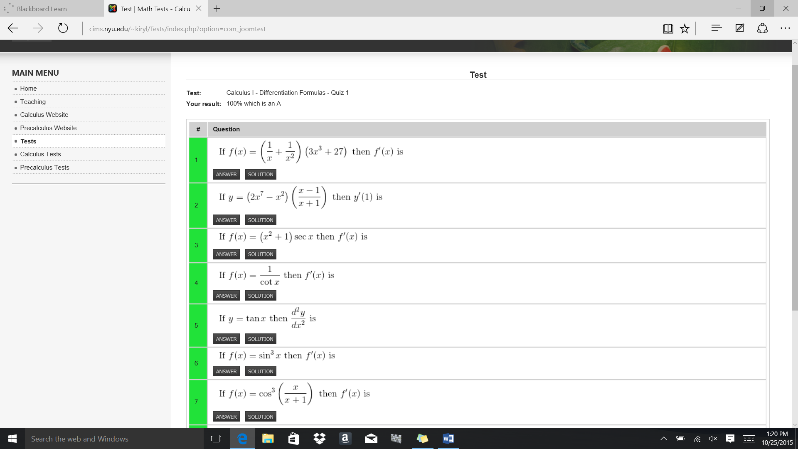

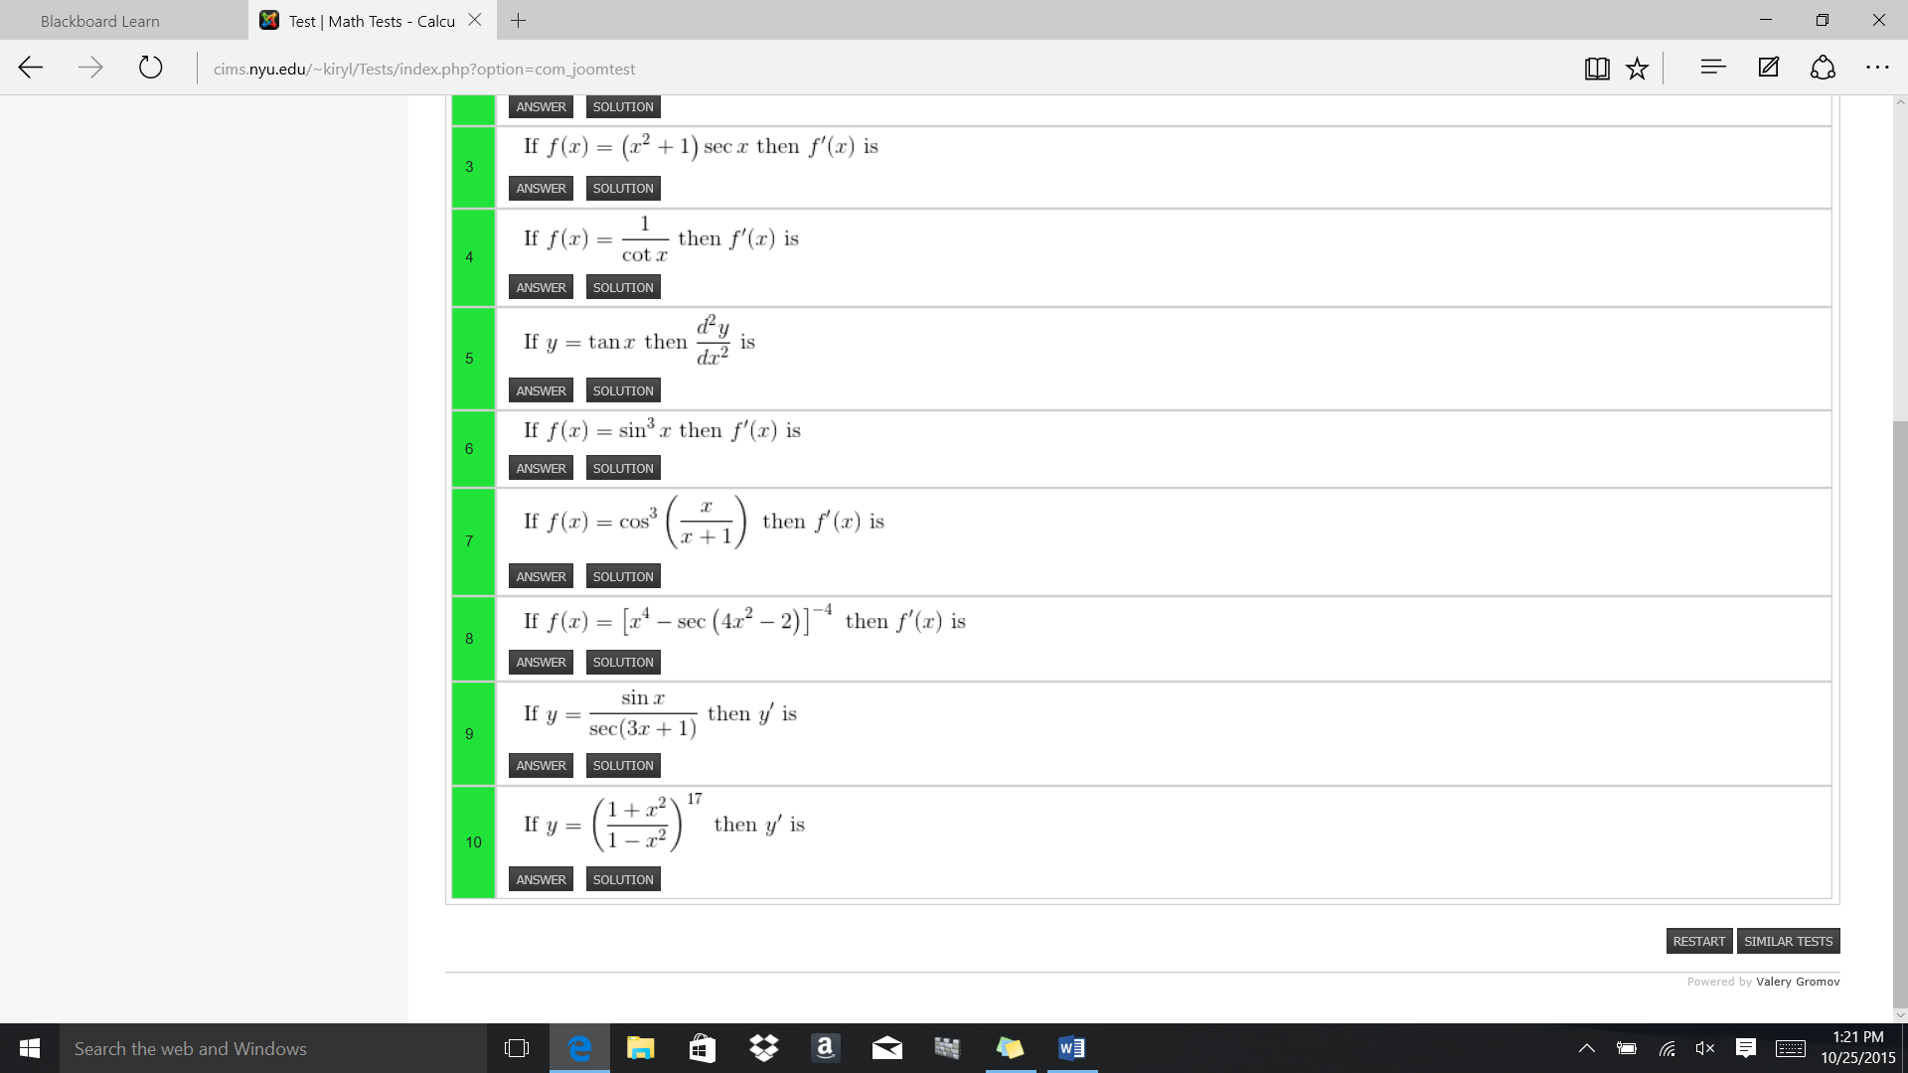

<http://cims.nyu.edu/~kiryl/Online%20Tests/Set_85.html> Test 1

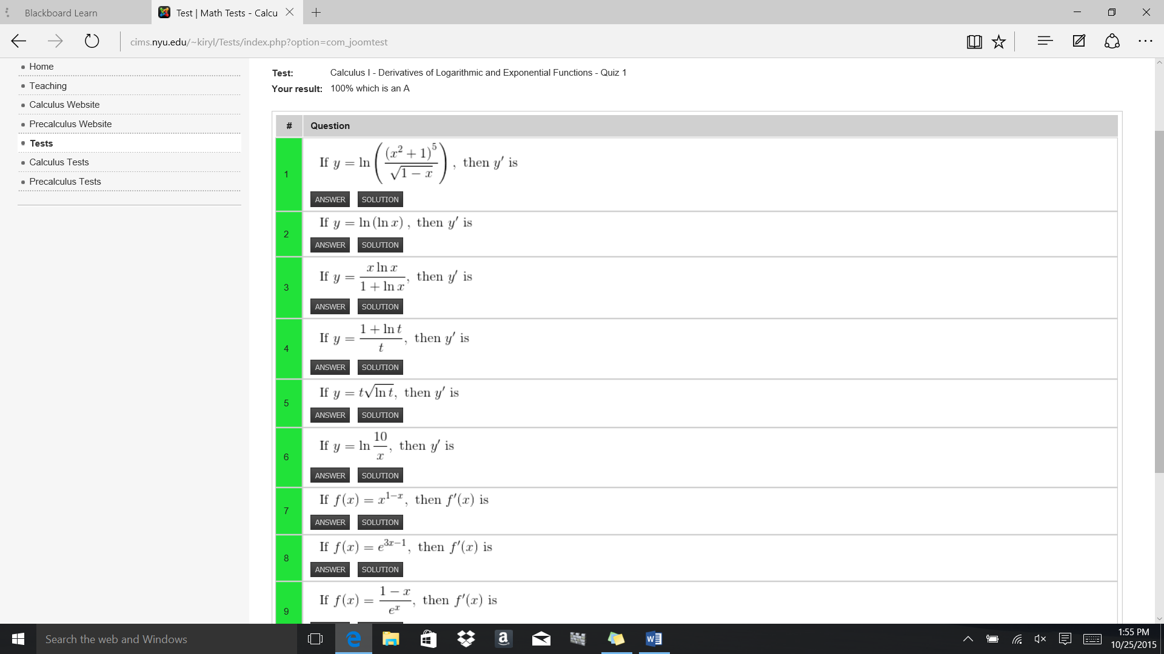

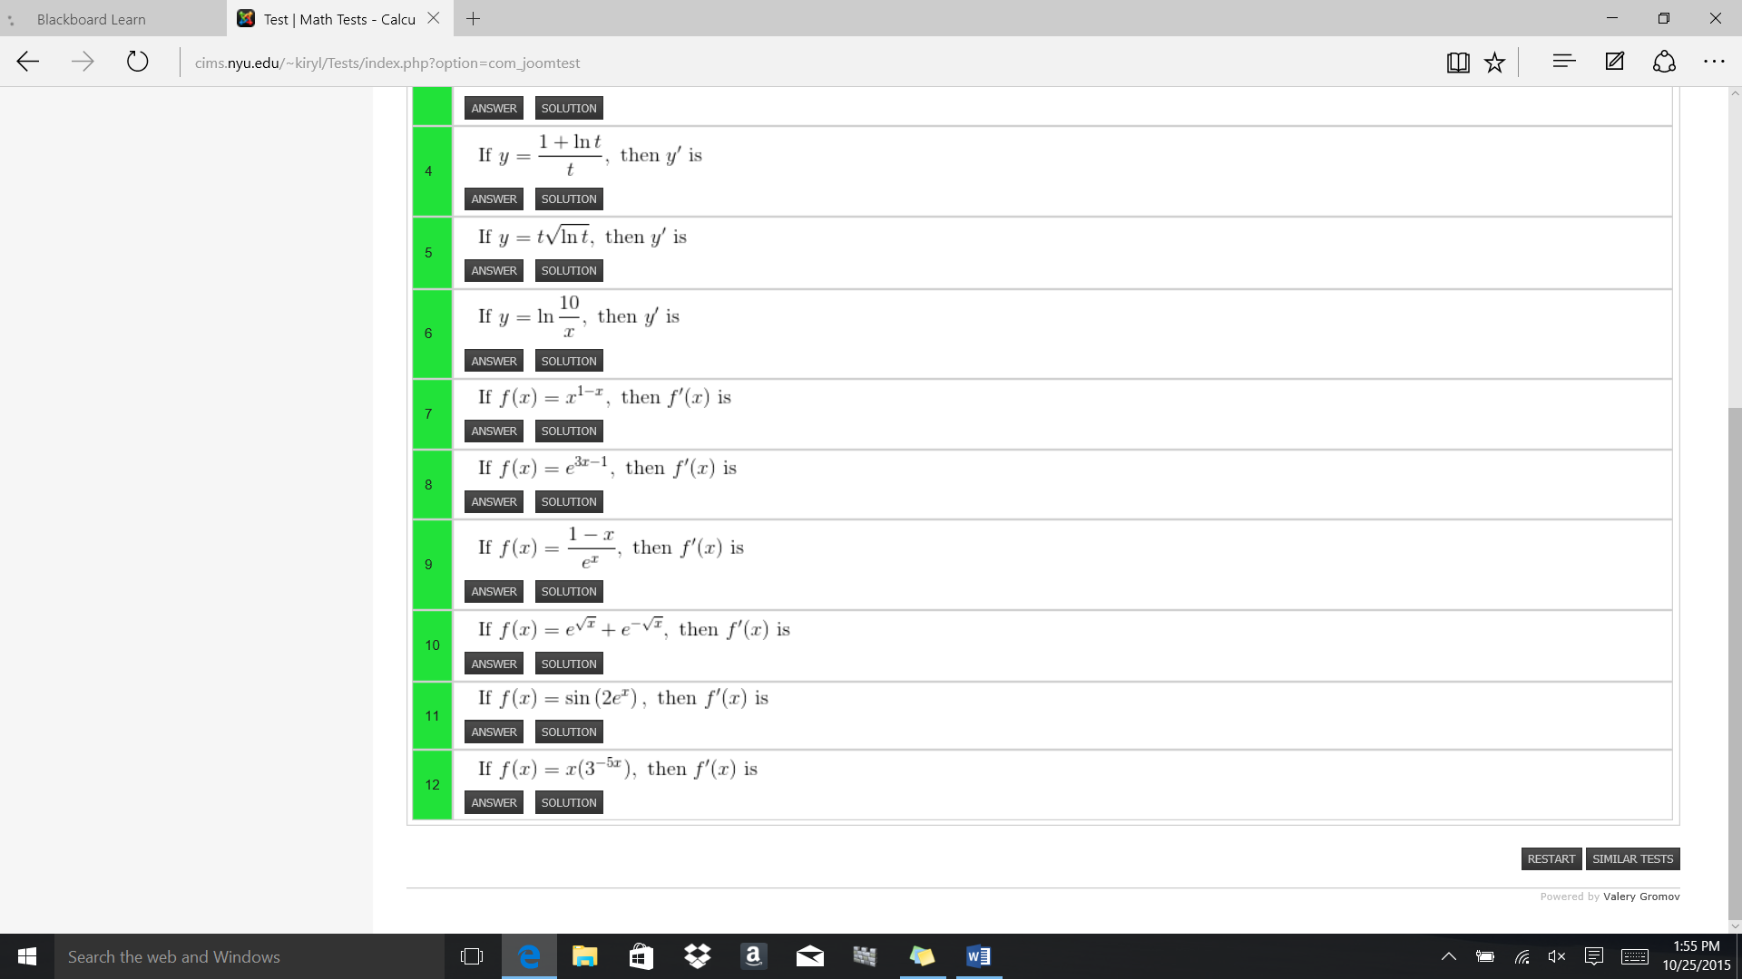

[http://cims.nyu.edu/~kiryl/Online%20Tests/Set_116.html Test 1](http://cims.nyu.edu/~kiryl/Online%20Tests/Set_116.html%20Test%201)

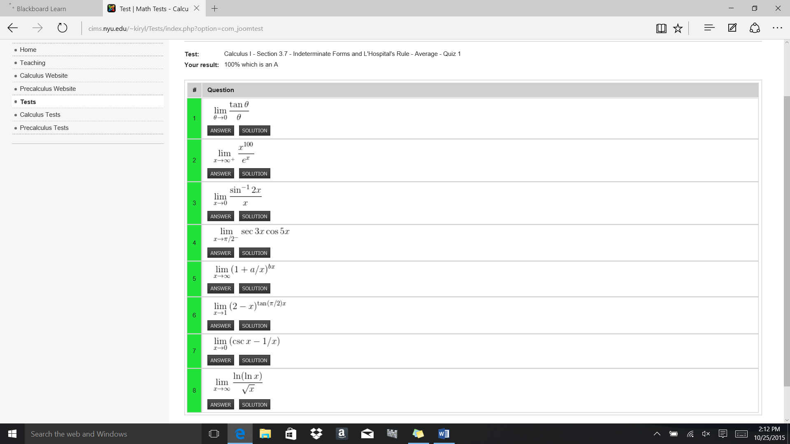

<http://cims.nyu.edu/~kiryl/Tests/index.php?option=com_joomtest&task=question&view=question&test_id=65&Itemid=53> Test 1

